# Section A: Original Wireframes

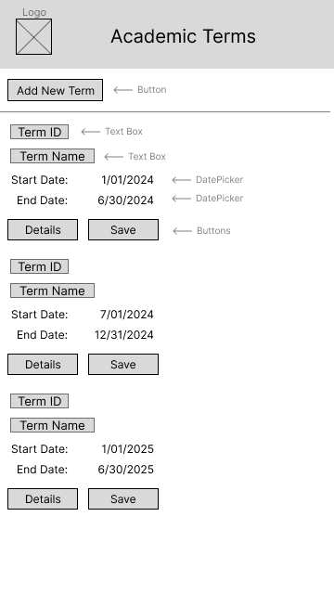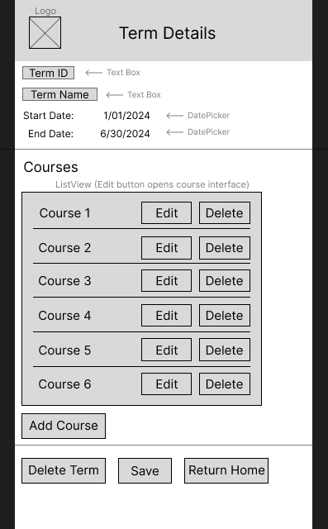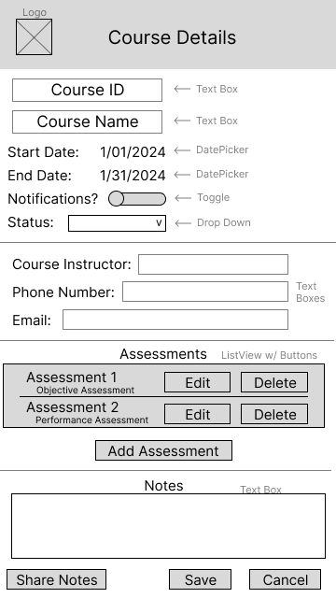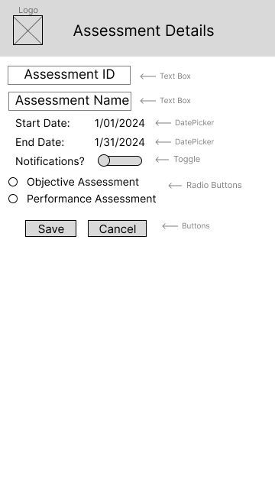

# Section C: Updated Wireframes

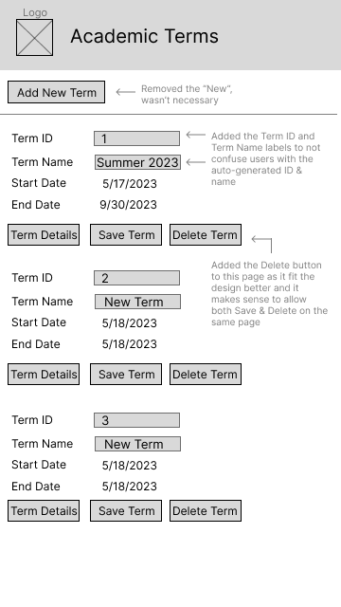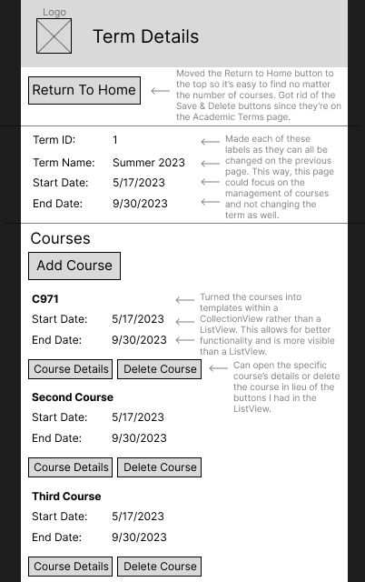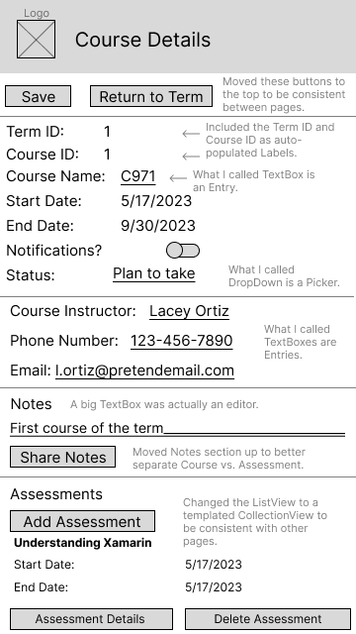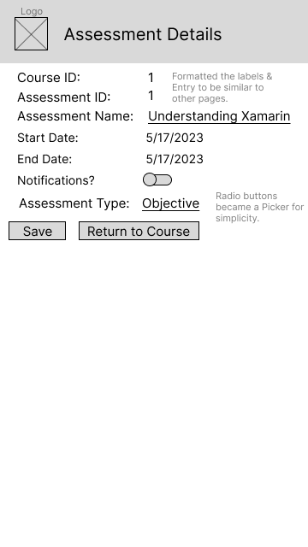

# Section E: Sources

Note: Sources have been cited in-line in the code per Course Instructor directions.

1. Montemagno, J. (2020, December 4). *Xamarin.Essentials - Xamarin*. Microsoft Learn. https://learn.microsoft.com/en-us/xamarin/essentials/
2. Dotnet-Bot. (n.d.). *DatePicker Class (Xamarin.Forms)*. Microsoft Learn. https://learn.microsoft.com/en-us/dotnet/api/Xamarin.Forms.DatePicker?view=xamarin-forms
3. Dotnet-Bot. (n.d.-b). *Picker Class (Xamarin.Forms)*. Microsoft Learn. https://learn.microsoft.com/en-us/dotnet/api/Xamarin.Forms.Picker?view=xamarin-forms
4. Edsnider. (n.d.). *GitHub - edsnider/localnotificationsplugin: Local Notifications Plugin for Xamarin and Windows*. GitHub. https://github.com/edsnider/LocalNotificationsPlugin